Fracture Energy and Charpy Impact Test

Materials Lab 10

Luke Bury

Lgb544

**1)**



Figure 1: Charpy Impact Energy vs Temperature of Specimen

Transition Temperature = 37.5°C

Three ways to determine the transition temperature at which the type of fracture changes from brittle to tough include analyzing the Charpy impact energy, as was done in this experiment, analyzing the percent of the fracture surface that’s got a brittle character, and comparing the width of a fractured end of material to the width of a free end of the same sample.

A major issue with transition temperature philosophy is that there’s no unified way of measuring and quantifying it. Transition temperature philosophy can only be used to qualitatively rank and relate materials tested under the same circumstances. As the thickness of a specimen increases, the transition temperature also increases, as shown in Figure 2.

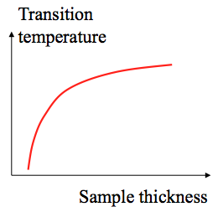

Figure 2: Trend demonstration of transition temperature vs sample thickness

**2)**

**3)**

**4)**

**5)**

Finding:

* Plane Stress Toughness: This is the KIC value when a,b 2
* A, n: Plot measured data for crack length versus time, and fit the data. The A and n both come from the fit. n can also be determined from the slope of the positive, increasing linear region on the plog of log(da/dt) versus log(k).
* Kth: Plot the log(da/dt) versus log(k) for measured data, as shown in Figure 3. Kth is the K value which marks the beginning of the positive, increasing linear region.
* Kp: On the same plot, this is the K value that marks the beginning of the flat, constant region.
* 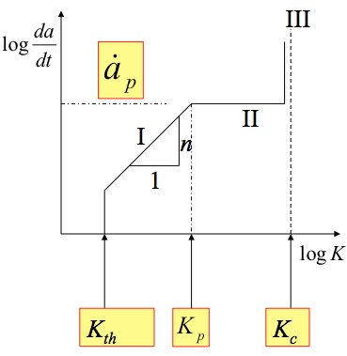ån: Under testing conditions, monitor the grown of the crack over time with a camera and small marks on the test specimen with measured space in between. This value can also be found from the location on the graph of Figure 3 where the flat region occurs.

Figure 3: Plot showing how to determine Kth and Kp.